# VISVESVARAYA TECHNOLOGICAL UNIVERSITY

## BELAGAVI – 590018, Karnataka INTERNSHIP REPORT

#### ON

“Full Stack Web Development”

***Submitted in partial fulfilment for the award of degree(21CSI85)***

## BACHELOR OF ENGINEERING IN

## COMPUTER SCIENCE AND ENGINEERING

***Submitted by:*** SHREYA(4MT20CS157),HARSHITHA(4MT20CS070),SHREYAS (4MT20IS040),PRABHANJAN(4MT20CS115)



Conducted at

**VARCONS TECHNOLOGIES PVT LTD**



# 

# MANGALORE INSTITUTE OF TECHNOLOGY

# Department of Computer Science And Engineering

# Badaga Mijar,Near Moodabidre,Mangalore Tq,

# DK Dist,Karnataka-574225

Mangalore Institute of Technology & Engineering

**Accredited by NBA, New Delhi**

# MANGALORE INSTITUTE OF TECHNOLOGY

# Department of Computer Science And Engineering

# Badaga Mijar,Near Moodabidre,Mangalore Tq,

# DK Dist,Karnataka-574225

Mangalore Institute of Technology & Engineering

**Accredited by NBA, New Delhi**



**CERTIFICATE**

This is to certify that the Internship titled **“Full Stack Web Development”** carried out by **SHREYA ,HARSHITHA,SHREYAS,PRABHANJAN** a bonafide student of Mangalore Institute of Technology and Engineering , in partial fulfillment for the award of **Bachelor of Engineering**, in **Computer Science And Engineering** **Branch & Information Science Branch** under **Visvesvaraya Technological University ,**  Belagavi , during the year 2022-2023.

The project report has been approved as it satisfies the academic requirements in respect of Internship prescribed for the course Internship / Professional Practice (21CSI85)

#### Signature of Guide Signature of HOD Signature of Principal

**External Viva:**

Name of the Examiner Signature with Date

1)

2)

# D E C L A R A T I O N

WE, **HARSHITHA,SHREYA,PRABHANJAN,SHREYAS**, third year student of Computer Science And Engineering, Mangalore Institute of Technology And Engineering - 574225, declare that the Internship has been successfully completed, in **Varcons Tecnologies Pvt Ltd**. This report is submitted in partial fulfillment of the requirements for award of Bachelor Degree in Computer Science And Engineering, during the academic year 2022-2023.

Date :25-02-2023

Place : Mangalore

USN &NAME: SHREYA(4MT20CS157)

HARSHITHA(4MT20CS070)

SHREYAS(4MT20IS040)

PRABHANJAN(4MT20CS115)

A C K N O W L E D G E M E N T

This Internship is a result of accumulated guidance, direction and support of several important persons. We take this opportunity to express our gratitude to all who have helped us to complete the Internship.

We express our sincere thanks to our Principal, for providing us adequate facilities to undertake this Internship.

We would like to thank our Head of Dept – branch code, for providing us an opportunity to carry out Internship and for his valuable guidance and support.

We would like to thank our (Lab assistant name) Software Services for guiding us during the period of internship.

We express our deep and profound gratitude to our guide, Guide name, Assistant/Associate Prof, for her keen interest and encouragement at every step in completing the Internship.

We would like to thank all the faculty members of our department for the support extended during the course of Internship.

We would like to thank the non-teaching members of our dept, for helping us during the Internship.

Last but not the least, we would like to thank our parents and friends without whose constant help, the completion of Internship would have not been possible.

SHREYA (4MT20CS157)

HARSHITHA(4MT20CS070)

SHREYAS(4MT20IS040)

PRABHANJAN(4MT20CS115)

# ABSTRACT

The online ordering System for a restaurant will make things easier for the customers.

The users need not waste their time waiting in the restaurant to order the items instead they can make use of the website.

This online ordering website enables the user to order anyrhing they wish to have without waiting .

There is also the exposure of the complete menu of the restaurant.There is also the POS order systems for in-house orders ,digital Payout ,Tabe resevation on demand which is possible through the website.

It also has Email and Whatsapp update tab for exciting offers and vouchers.

This online ordering system has multiple features such as Add ,Delete and Update of items that can be done before placing an order.

A user can choose from the different items, can make online payments and will get the items at the doorstep.

This system is developed using HTML , CSS, JavaScript and Bootstrap.

This images may be subjected to copyright.

# Table of Contents

|  |  |  |
| --- | --- | --- |
| **Sl no** | **Description** | **Page no** |
| 1 | Company Profile | 10 |
| 2 | About the Company | 12 |
| [3](https://1.bp.blogspot.com/-dODuK8N5h1Q/Wlnyb3V9HFI/AAAAAAAACL4/WxQtCJ1pM5wccDABg4wIrTBUB0vlikXQQCLcBGAs/s1600/poly1.jpg) | Introduction | 15 |
| [4](https://1.bp.blogspot.com/-dODuK8N5h1Q/Wlnyb3V9HFI/AAAAAAAACL4/WxQtCJ1pM5wccDABg4wIrTBUB0vlikXQQCLcBGAs/s1600/poly1.jpg) | System Analysis | 18 |
| [5](https://1.bp.blogspot.com/-dODuK8N5h1Q/Wlnyb3V9HFI/AAAAAAAACL4/WxQtCJ1pM5wccDABg4wIrTBUB0vlikXQQCLcBGAs/s1600/poly1.jpg) | Requirement Analysis | 20 |
| 6 | Design [Analysis](https://4.bp.blogspot.com/-IOOxgPaXMVc/Wlj3LWvcnjI/AAAAAAAACKE/UeTFYvAxDmUDel5UBjdifeWaApB3-dXVgCLcBGAs/s1600/img1.jpg) | 22 |
| 7 | [Implementation](https://4.bp.blogspot.com/-IOOxgPaXMVc/Wlj3LWvcnjI/AAAAAAAACKE/UeTFYvAxDmUDel5UBjdifeWaApB3-dXVgCLcBGAs/s1600/img1.jpg) | 24 |
| 8 | Snapshots | 26 |
| 9 | Conclusion | 37 |
| 10 | References | 39 |

[**CHAPTER**](https://1.bp.blogspot.com/-dODuK8N5h1Q/Wlnyb3V9HFI/AAAAAAAACL4/WxQtCJ1pM5wccDABg4wIrTBUB0vlikXQQCLcBGAs/s1600/poly1.jpg) **1** **COMPANY PROFILE**

# COMPANY PROFILE

**A Brief History of Varcons Technologies**

Varcons Technologies Private Limited is a Private incorporated on 11 July 2022. It is classified as Non-govt company and is registered at Registrar of Companies, Bangalore. Its authorized share capital is Rs. 1,000,000 and its paid up capital is Rs. 10,000. It is inolved in Other computer related activities [for example maintenance of websites of other firms/ creation of

multimedia presentations for other firms etc.].

Varcons Technologies Private Limited's Annual General Meeting (AGM) was last held on N/A and as per records from Ministry of Corporate Affairs (MCA), its balance sheet was last filed on N/A.

Directors of Varcons Technologies Private Limited are Haralahalli Chandraiah Spoorthi and

Chikaegowdanadoddi Kariyappa Somalatha. Varcons is a preferred Cloud Solution Provider

and Public Sector Reseller for Federal and State Governments across multiple Cloud Service

Provider. Our Cloud adoption and migration services brings together latest technologies, and

best practices to accelerate Cloud adoption to your firm.

Our years of experience in the Federal sector and utilizing best practices picked up along the way, we design and build a cloud infrastructure that suitable for your enterprise, focus on being secure, and compliant.They develop websites that behave and interact similar to s ophisticated software. They offer professional Graphic design, Brochure design & Logo design.

We are experts in crafting visual content to convey the right message to the customers. They also design custom wraps for your products(also known as package designing). They help you manage your SEO campaign more efficiently and effectively. We help you gain market share by leveraging our expertise. Our holistic approach to identify anything that may be hurting your traffic or rankings and show you just how to outrank the competition.

VCA provides a host of services to its customers/users/clients, Enabling business success

driven by technology Harnessing the power of technology, we create a measurable difference

for our clients across various industries & multiple geographies.They work with Consumer Electronics, Lighting, Home Automation, Metering, Sensor Technology, Home Appliance and

Medical Device companies to help them create smart and connected products. Through its integrated Embedded and IoT services, VCA helps build intelligent & connected devices that can be remotely monitored and controlled while

leveraging edge and cloud computing for a host of intelligent applications and analytics.

**CHAPTER 2: ABOUT COMPANY**

1. **ABOUT THE COMPANY**



## ABOUT THE COMPANY

Varcons Technologies is a Technology Organization providing solutions for all web design and development, MYSQL, PYTHON Programming, HTML, CSS, ASP.NET. With the Right Software, Service and Analytics, Great Things Can Happen. Smart solutions are at the core of all that they do at VCT. Their main goal is to find smart ways of using technology that will help build a better tomorrow for everyone, everywhere.

SaaS offers a variety of advantages over traditional software licensing models and here at VCT tend to include the key features of SaaS in everything we build. At VCT, they make sure every product/service that we offer is built keeping in mind the practical usability of the product/Service, they are a startup focused on Creativity and Customizability, and We also provide subscription models for Software that we have already built, Since the application is already configured, the user has a ready-to-use application.

This not only reduces installation and configuration time but also cuts down the time

wasted on potential glitches linked to software deployment.

Service of Varcons Technologies. Website as Software They develop websites that behave and interact similar to Sophisticated software. Information+ Functionality= WaaS Analytics and Research They analyze the way your users/customers interact with you/your business by gathering, studying, and understanding the consumer voice and their perception of the product/service to generate a report to help you make better market decisionsProducts of Compsoft Technologies.

Comprehensive Customer Support With a comprehensive range of services, We can guarantee your technology needs are not just met, but exceeded. We shall work with your Customers/users closely to understand the way your users/customers use/make use of Products/Services.

Branding and Design We offer professional Graphic design, Brochure design & Logo design. We are experts in crafting visual content to convey the right message to the customers. We also design custom wraps for your products(also known as package designing).

Search Engine Optimization We help you manage your SEO campaign more efficiently and effectively. We help you gain market share by leveraging our expertise. our holistic approach to identify anything that may be hurting your traffic or rankings and show you just how to outrank the competition. Embedded Systems and IOT We work with Consumer Electronics, Lighting, Home Automation, Metering, Sensor-Technology, Home Appliance and Medical Device companies to help them create smart and connected products.

Through its integrated Embedded and IoT services, VCA helps build intelligent & connected devices that can be remotely monitored and controlled while leveraging edge and cloud computing for a host of intelligent applications and analytics. Comprehensive Customer Support With a comprehensive range of services, we guarantee your technology needs are not just met, but exceeded. We shall work with your customers/users closely to understand the way your users/customers use/make use of products/services.

## Departments and services offered

Varcon Technologies plays an essential role as an institute, the level of education, development of student’s skills are based on their trainers. If you do not have a good mentor then you may lag in many things from others and that is why we at Varcon Technologies gives you the facility of skilled employees so that you do not feel unsecured about the academics. Personality development and academic status are some of those things which lie on mentor’s hands. If you are trained well then you can do well in your future and knowing its importance of Varcon Technologies always tries to give you the best.

They have a great team of skilled mentors who are always ready to direct their trainees in the best possible way they can and to ensure the skills of mentors we held many skill development programs as well so that each and every mentor can develop their own skills with the demands of the companies so that they can prepare a complete packaged trainee.

## Services provided by Varcon Technologies:

VCA provides a host of services to its customers/users/clients, Enabling business success driven by technology Harnessing the power of technology, we create a measurable difference for our clients across various industries & multiple geographies.

* **Website as Software**

They develop websites that behave and interact similar to sophisticated software.

* **Search Engine Optimisation**

They help you manage your SEO campaign more efficiently and effectively. We help you gain market share by leveraging our expertise. our holistic approach to identify anything that may be hurting your traffic or rankings and show you just how to outrank the competition.

* **Comprehensive Customer Support**

With a comprehensive range of services, we guarantee your technology needs are not just met, but exceeded. We shall work with your customers/users closely to understand the way your users/customers use/make use of products/services.

* **Branding and Design**

They offer professional Graphic design, Brochure design & Logo design. We are experts in crafting visual content to convey the right message to the customers.We also design custom wraps for your products(also known as package designing)

* **Analytics and Research**

They analyse the way your users/customers interact with you/your business by gathering, studying and understanding the consumer voice and their perception of the product/service.

* **Embedded Systems and IOT**

They work with Consumer Electronics, Lighting, Home Automation, Metering, Sensor-Technology, Home Appliance and Medical Device companies to help them create smart and connected products. Through its integrated Embedded and IoT services, VCA helps build intelligent & connected devices that can be remotely monitored and controlled while leveraging edge and cloud computing for a host of intelligent applications and analytics.

# [CHAPTER](https://1.bp.blogspot.com/-dODuK8N5h1Q/Wlnyb3V9HFI/AAAAAAAACL4/WxQtCJ1pM5wccDABg4wIrTBUB0vlikXQQCLcBGAs/s1600/poly1.jpg) 3 INTRODUCTION

**3.INTRODUCTION**

## Introduction to Web Apps

Web applications are similar to the traditional applications you’d install on your Information, such as Microsoft Office. They are able to perform the same kinds of tasks, they look the same and they feel the same but there is one key difference - the application itself is not installed on your phone or Information, but lives in the cloud. Web apps are not new, but it used to be that they were often unable to compete with more traditional applications for business critical functions or where rich user interaction was required. This is no longer the case. With the power of modern web technologies, we are able to design and build performing, secure, and feature rich applications that live in the cloud and bring with them a huge number of benefits.

#### They can be accessed from anywhere.

* Because web applications are built with web technologies and they run in a web browser Internet Explorer, Google Chrome, Mozilla Firefox – this allows them to be accessed from every web enabled tool. As long as you have an internet connection you can use them.
* It allows for remote working, it allows for rapid publishing of content, it allows for real time collaboration between teams. If you have web access, you have the ability to access your business tools.

#### They are cost effective.

* Web applications are cheaper to produce and maintain than traditional applications. No matter how many platforms your business uses (Mac, Linux, Windows) web application build can be used across them all.

#### They benefit from more rapid update cycles.

* A huge benefit of web applications is that when an update is released, all of your users are immediately using that version. This doesn’t happen with installed applications, especially in large organizations with IT policies that restrict administrator access.

#### They are secure.

* Web developers have had to become experts in security – the web is a platform designed to share everything with everyone! As such, the types and levels of security included in web applications are often far greater than those seen in traditional applications.
* They also benefit from the ability to launch updates in real-time – the application on the servers is the application people are using. The applications on people’s laptops however is the version last installed. And when those laptops get left on a train it’s not a concern, as nothing is stored locally.

#### They enable more computing with fewer Information.

* Web applications push all of the hard work to the servers, and act as intermediaries between the user interface and the calculations happening behind the scenes. This means you can accomplish terrifyingly complex work on a tablet, or your phone.
* We’ve built web applications that allow people to understand the complex relationships between 250,000 pieces of art on their phones, and applications that run the business systems of one of the largest solar energy providers in the world. Often these products are not financially viable to build using traditional application processes.

## Problem Statement

Develop an application which facilitates creation of web pages having a need to install any HTML editor based software and also which can be used by any novice user (no HTML knowledge needed) that is developing web pages on the online. This module is designed to reduce the process involved in managing the activity of customers and business where the business can sell their services and the customers can buy those.

## Introduction to B2C Ecommerce Website Development with Admin Panel

B2C E-commerce website content providers to focus on creating effective assessment questions and focusing on providing a platform for easy access between Buyer and Consumer.

Here we present techniques that are pertinent to the elements of assessment process: answers submission, Informationized grading, and feedback after submission. As the modern organizations are automated and Informations are working as per the instructions, it becomes essential for the coordination of human beings, commodity and Informations in a modern

organization.

# [CHAPTER](https://1.bp.blogspot.com/-dODuK8N5h1Q/Wlnyb3V9HFI/AAAAAAAACL4/WxQtCJ1pM5wccDABg4wIrTBUB0vlikXQQCLcBGAs/s1600/poly1.jpg) 4 SYSTEM ANALYSIS

**4. SYSTEM ANALYSIS**

## Existing System

## Proposed System

## Objective of the System

# [CHAPTER](https://1.bp.blogspot.com/-dODuK8N5h1Q/Wlnyb3V9HFI/AAAAAAAACL4/WxQtCJ1pM5wccDABg4wIrTBUB0vlikXQQCLcBGAs/s1600/poly1.jpg) 5 REQUIREMENT ANALYSIS

**5. REQUIREMENT ANALYSIS**

## Hardware Requirement Specification

* + MySQL
  + NODE JS
  + Notepad++ Editor
  + Processor: Intel core i5 processer
  + Memory: 15.6 GB
  + Hard Disk: 40 GB

## Software Requirement Specification

### Functional Requirements

### Non-Functional Requirements

#### Availability

The online registration system shall permit backing up of the registration database while other registration actives are going on.

#### Accessibility

The system shall be accessible by people with specific vision needs to the extent that a user shall be able to display whole user interface in a larger font without truncating displayed text or other values.

#### Security

The access permissions for system data may only be change by the systems data administrator passwords shall never be viewable at the point of entry or any other time.

# [CHAPTER](https://1.bp.blogspot.com/-dODuK8N5h1Q/Wlnyb3V9HFI/AAAAAAAACL4/WxQtCJ1pM5wccDABg4wIrTBUB0vlikXQQCLcBGAs/s1600/poly1.jpg) 6 DESIGN ANALYSIS

1. **DESIGN & ANALYSIS**

# [CHAPTE](https://1.bp.blogspot.com/-dODuK8N5h1Q/Wlnyb3V9HFI/AAAAAAAACL4/WxQtCJ1pM5wccDABg4wIrTBUB0vlikXQQCLcBGAs/s1600/poly1.jpg)R 7 IMPLEMENTATION

1. **IMPLEMENTATION**

Implementation is the stage where the theoretical design is turned into a working system. The most crucial stage in achieving a new successful system and in giving confidence on the new system for the users that it will work efficiently and effectively.

The system can be implemented only after thorough testing is done and if it is found to work according to the specification. It involves careful planning, investigation of the current system and it constraints on implementation, design of methods to achieve the change over and an evaluation of change over methods a part from planning.

Two major tasks of preparing the implementation are education and training of the users and testing of the system. The more complex the system being implemented, the more involved will be the system analysis and design effort required just for implementation.

The implementation phase comprises of several activities. The required hardware and software acquisition is carried out. The system may require some software to be developed. For this, programs are written and tested. The user then changes over to his new fully tested system and the old system is discontinued.

## TESTING

The testing phase is an important part of software development. It is the Information zed system will help in automate process of finding errors and missing operations and also a complete verification to determine whether the objectives are met and the user requirements are satisfied. Software testing is carried out in three steps:

1. The first includes unit testing, where in each module is tested to provide its correctness, validity and also determine any missing operations and to verify whether the objectives have been met. Errors are noted down and corrected immediately.
2. Unit testing is the important and major part of the project. So errors are rectified easily in particular module and program clarity is increased. In this project entire system is divided into several modules and is developed individually. So unit testing is conducted to individual modules.
3. The second step includes Integration testing. It need not be the case, the software whose modules when run individually and showing perfect results, will also show perfect results when run as a whole.

# [CHAPTE](https://1.bp.blogspot.com/-dODuK8N5h1Q/Wlnyb3V9HFI/AAAAAAAACL4/WxQtCJ1pM5wccDABg4wIrTBUB0vlikXQQCLcBGAs/s1600/poly1.jpg)R 8 SNAPSHOTS

* 1. **SNAPSHOTS**

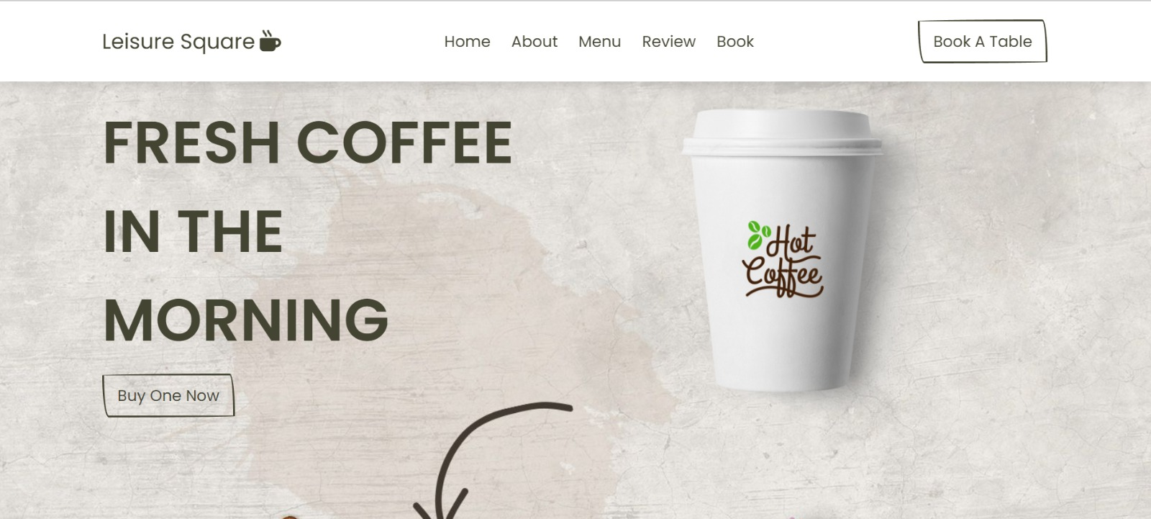



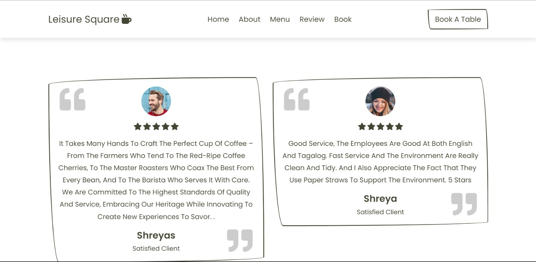

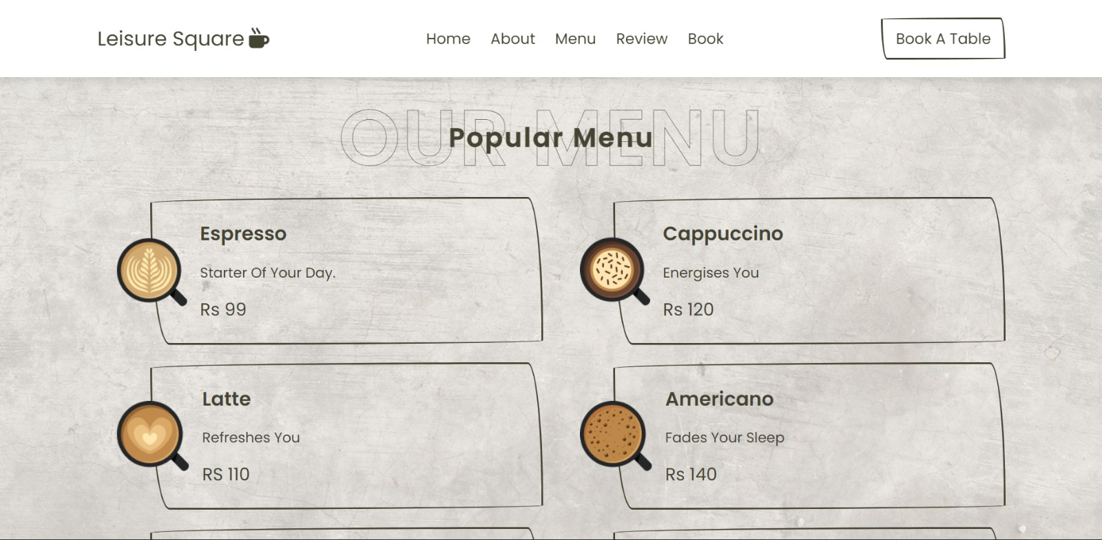

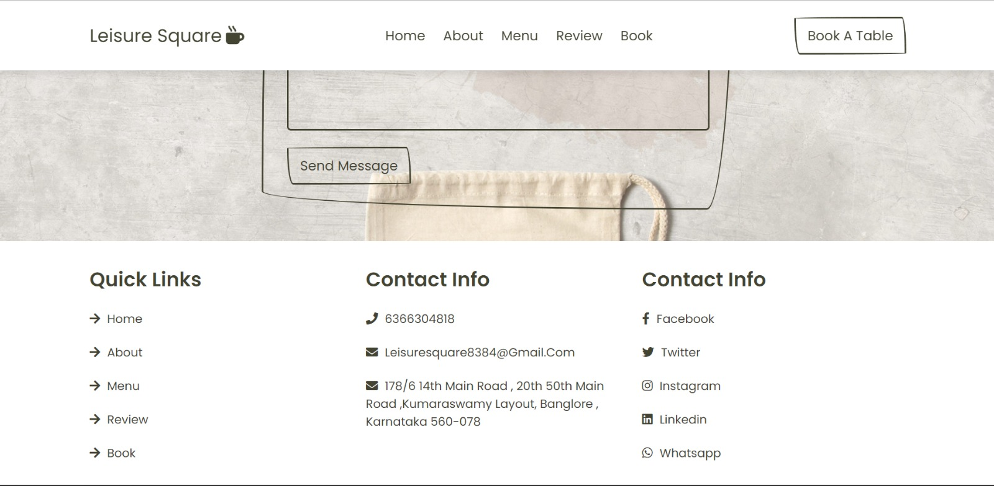



# [CHAPTE](https://1.bp.blogspot.com/-dODuK8N5h1Q/Wlnyb3V9HFI/AAAAAAAACL4/WxQtCJ1pM5wccDABg4wIrTBUB0vlikXQQCLcBGAs/s1600/poly1.jpg)R 9 CONCLUTION

* 1. **CONCLUTION**

The package was designed in such a way that future modifications can be done easily. The following conclusions can be deduced from the development of the project:

* Automation of the entire system improves the efficiency
* It provides a friendly graphical user interface which proves to be better when compared to the existing system.
* It gives appropriate access to the authorized users depending on their permissions.
* It effectively overcomes the delay in communications.
* Updating of information becomes so easier
* System security, data security and reliability are the striking features.
* The System has adequate scope for modification in future if it is necessary.

# REFERENCE

* W3school.com
* Github.com